Steps to Create a Free Power BI Work Account
Even though creating a Power BI account may seem like an easy task, people often get stuck in this process. Creating it is important because it publishes Power BI reports and uses more visuals, ultimately allowing you to get the most out of it. I will explain how to create a power BI work account for free.
- First, when you enter power BI, it will look like this. When you click on sign in, it will ask for a work account to sign in.
- 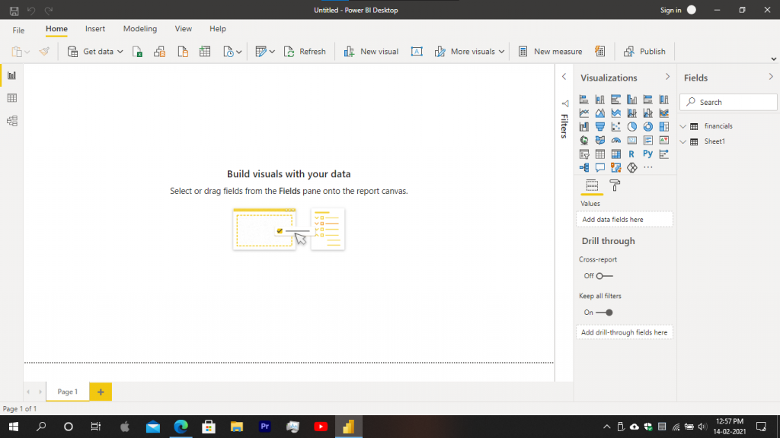Go to Microsoft.com and log in with your personal account which you used to log in to windows.
- 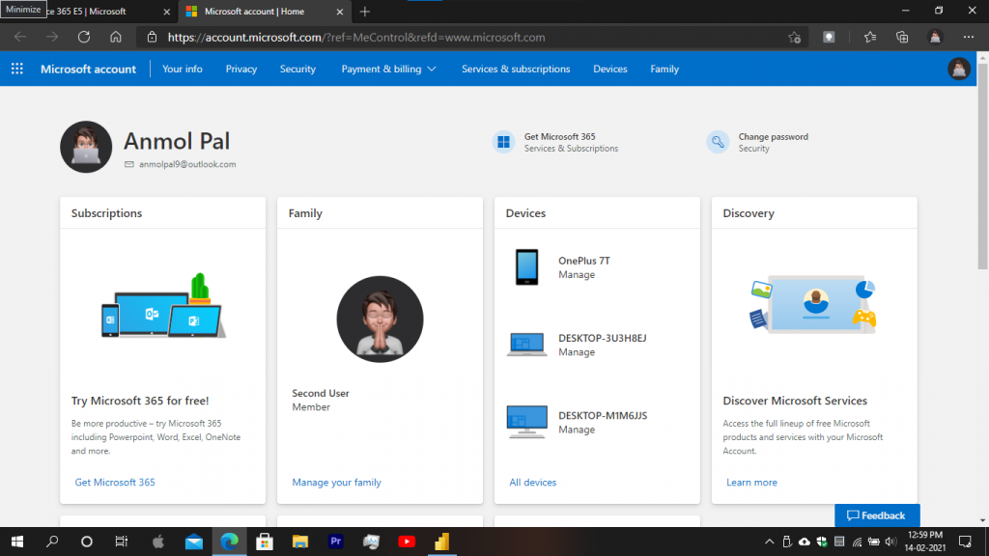Open your web browser and search for office 365 E5. You will see a page like this. Click on the free trial.
- In this window, enter your personal email address and click on next.
- 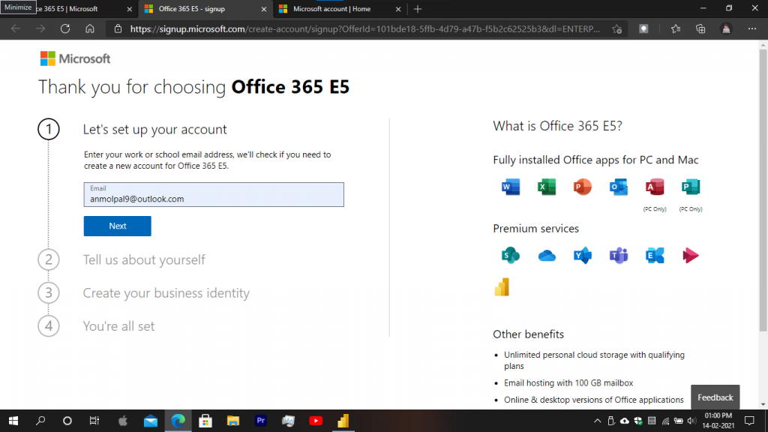In the next step, it will ask for your details. Fill up the information and click next.
- Now, in the next step, create your business identity by entering your business name. Create a unique business name and click on next.
- 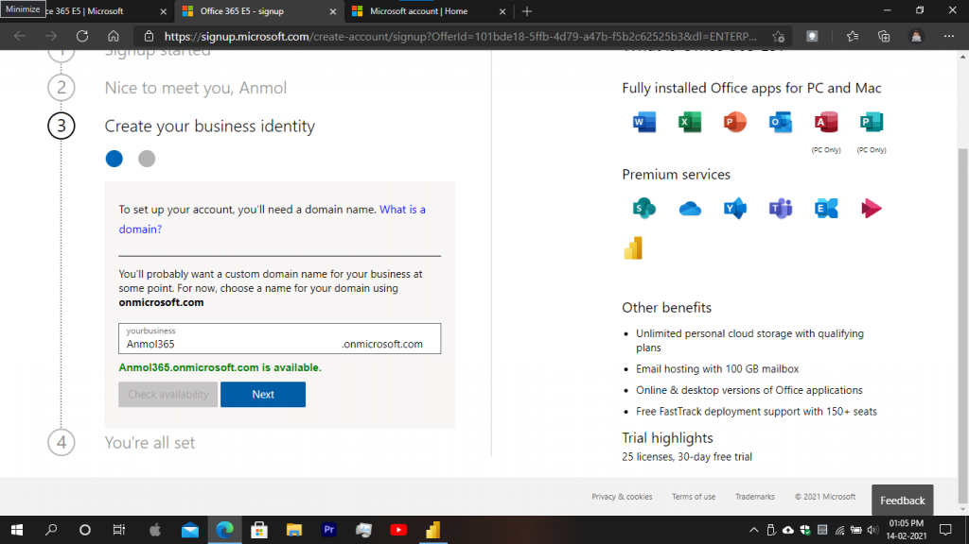Now, create a unique password for your account and be sure you remember it. You can paste your password into a notepad file and save it. After that, click on sign up.
- 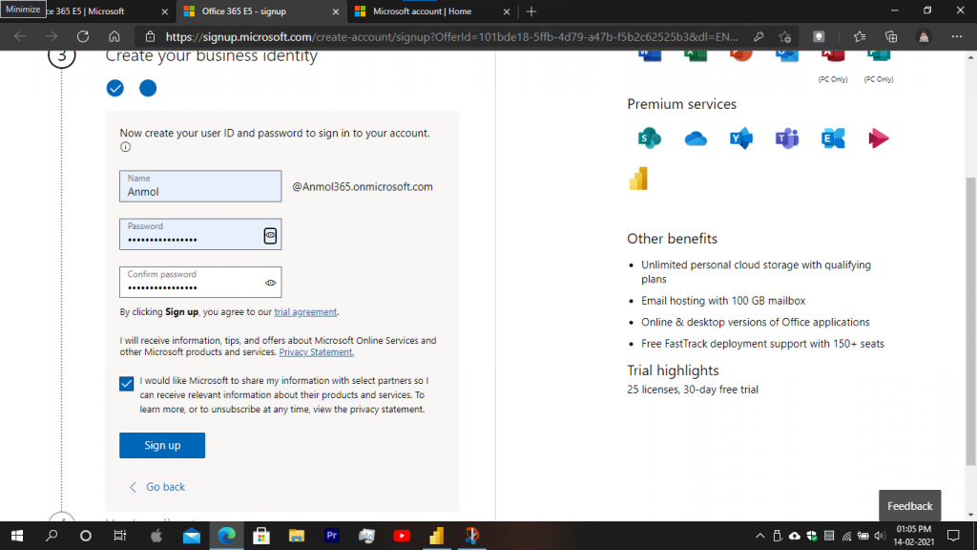After clicking on the sign-up, a page will appear like this. It will show your work account username with the domain name registered to Microsoft.com. Copy this work account username to a notepad file in case you forgot it. Click on get started, and it will take you to a different web page where you can see your power BI published files and also work online on Power BI. Also got to your personal email address and verify your Power BI work account.
- 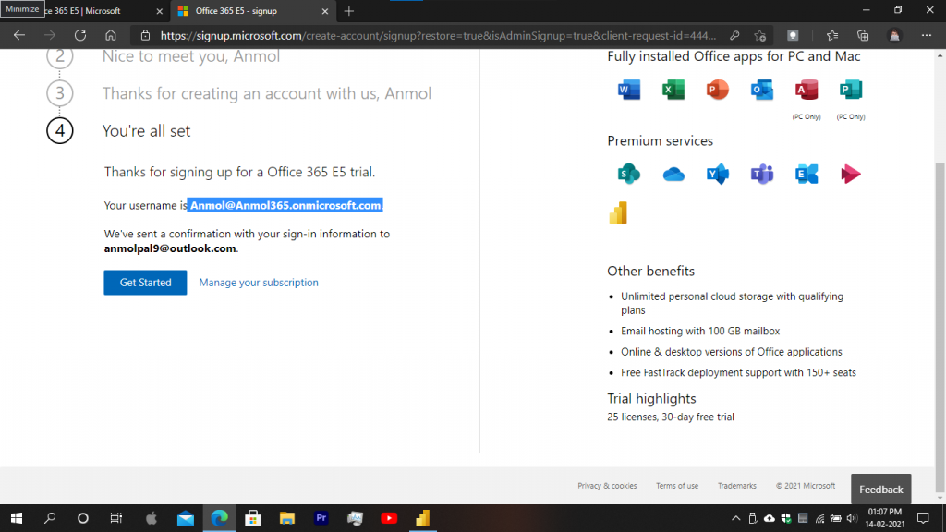Open the Power BI desktop, and at the upper right corner, you can see the sign-in option. Click on the sign-in option, and a pop-up will appear asking for your work account address. Copy your work account from the notepad and paste it on the sign-in pop-up. After that, click on continue. After some time, it will ask for the password. It will take some time to log sign in because it will authenticate you with the Power BI server. Enter your password, and you are successfully signed in.
- 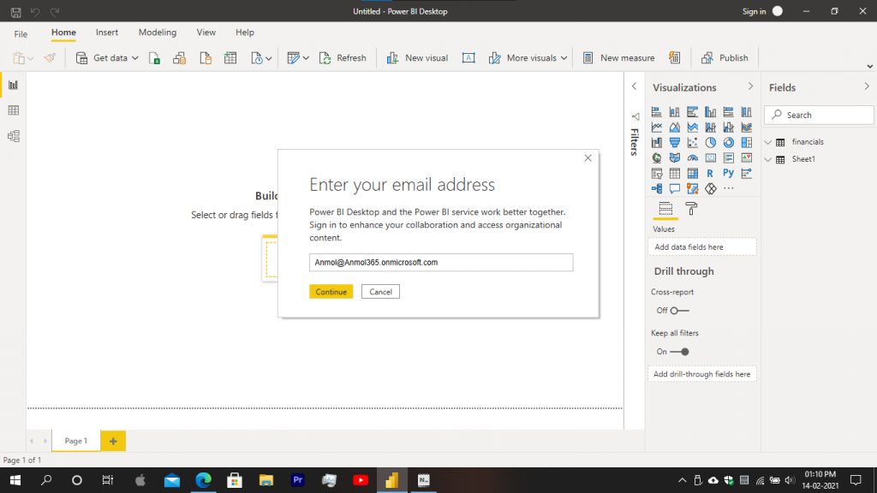After you successfully sign in to your account, the page will appear like this in which your power BI work account is shown.
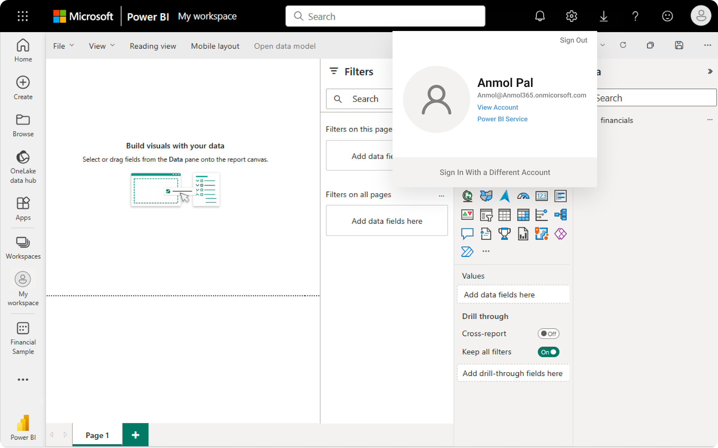

Conclusion
The above point contains a step-by-step guide to creating a work account in Microsoft Power BI

